WORKING MODES
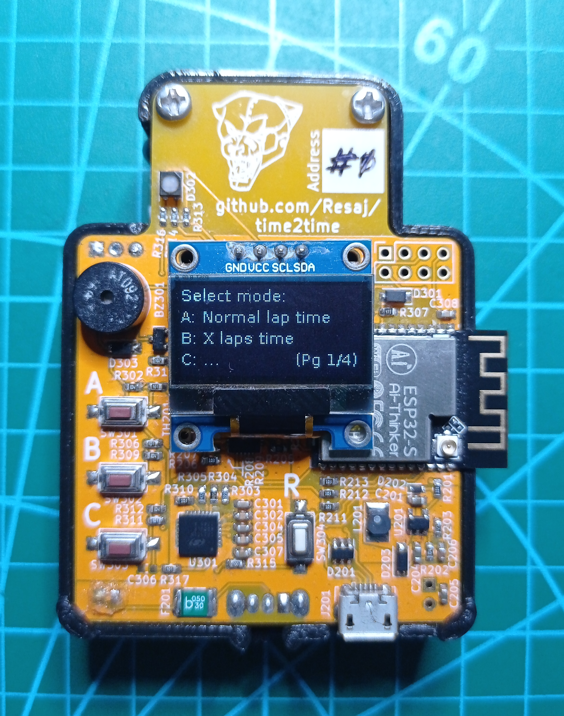
The working modes can be seen by scrolling through the menu when the C button is pressed. When you find the desired mode, just click the button (A or B) that shows the menu to enter it.
In the bottom right of the screen you’ll see the amount of pages that the menu has and the page you are in.
Once you have entered the mode, you can get out of it by pressing the C button.

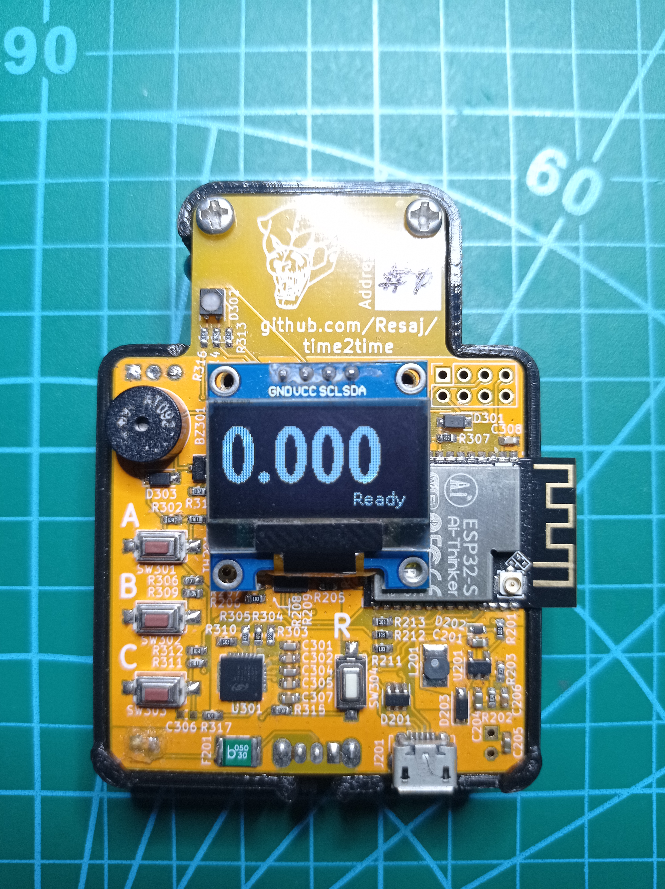
Normal lap time
- Displays the lap time on a closed circuit.
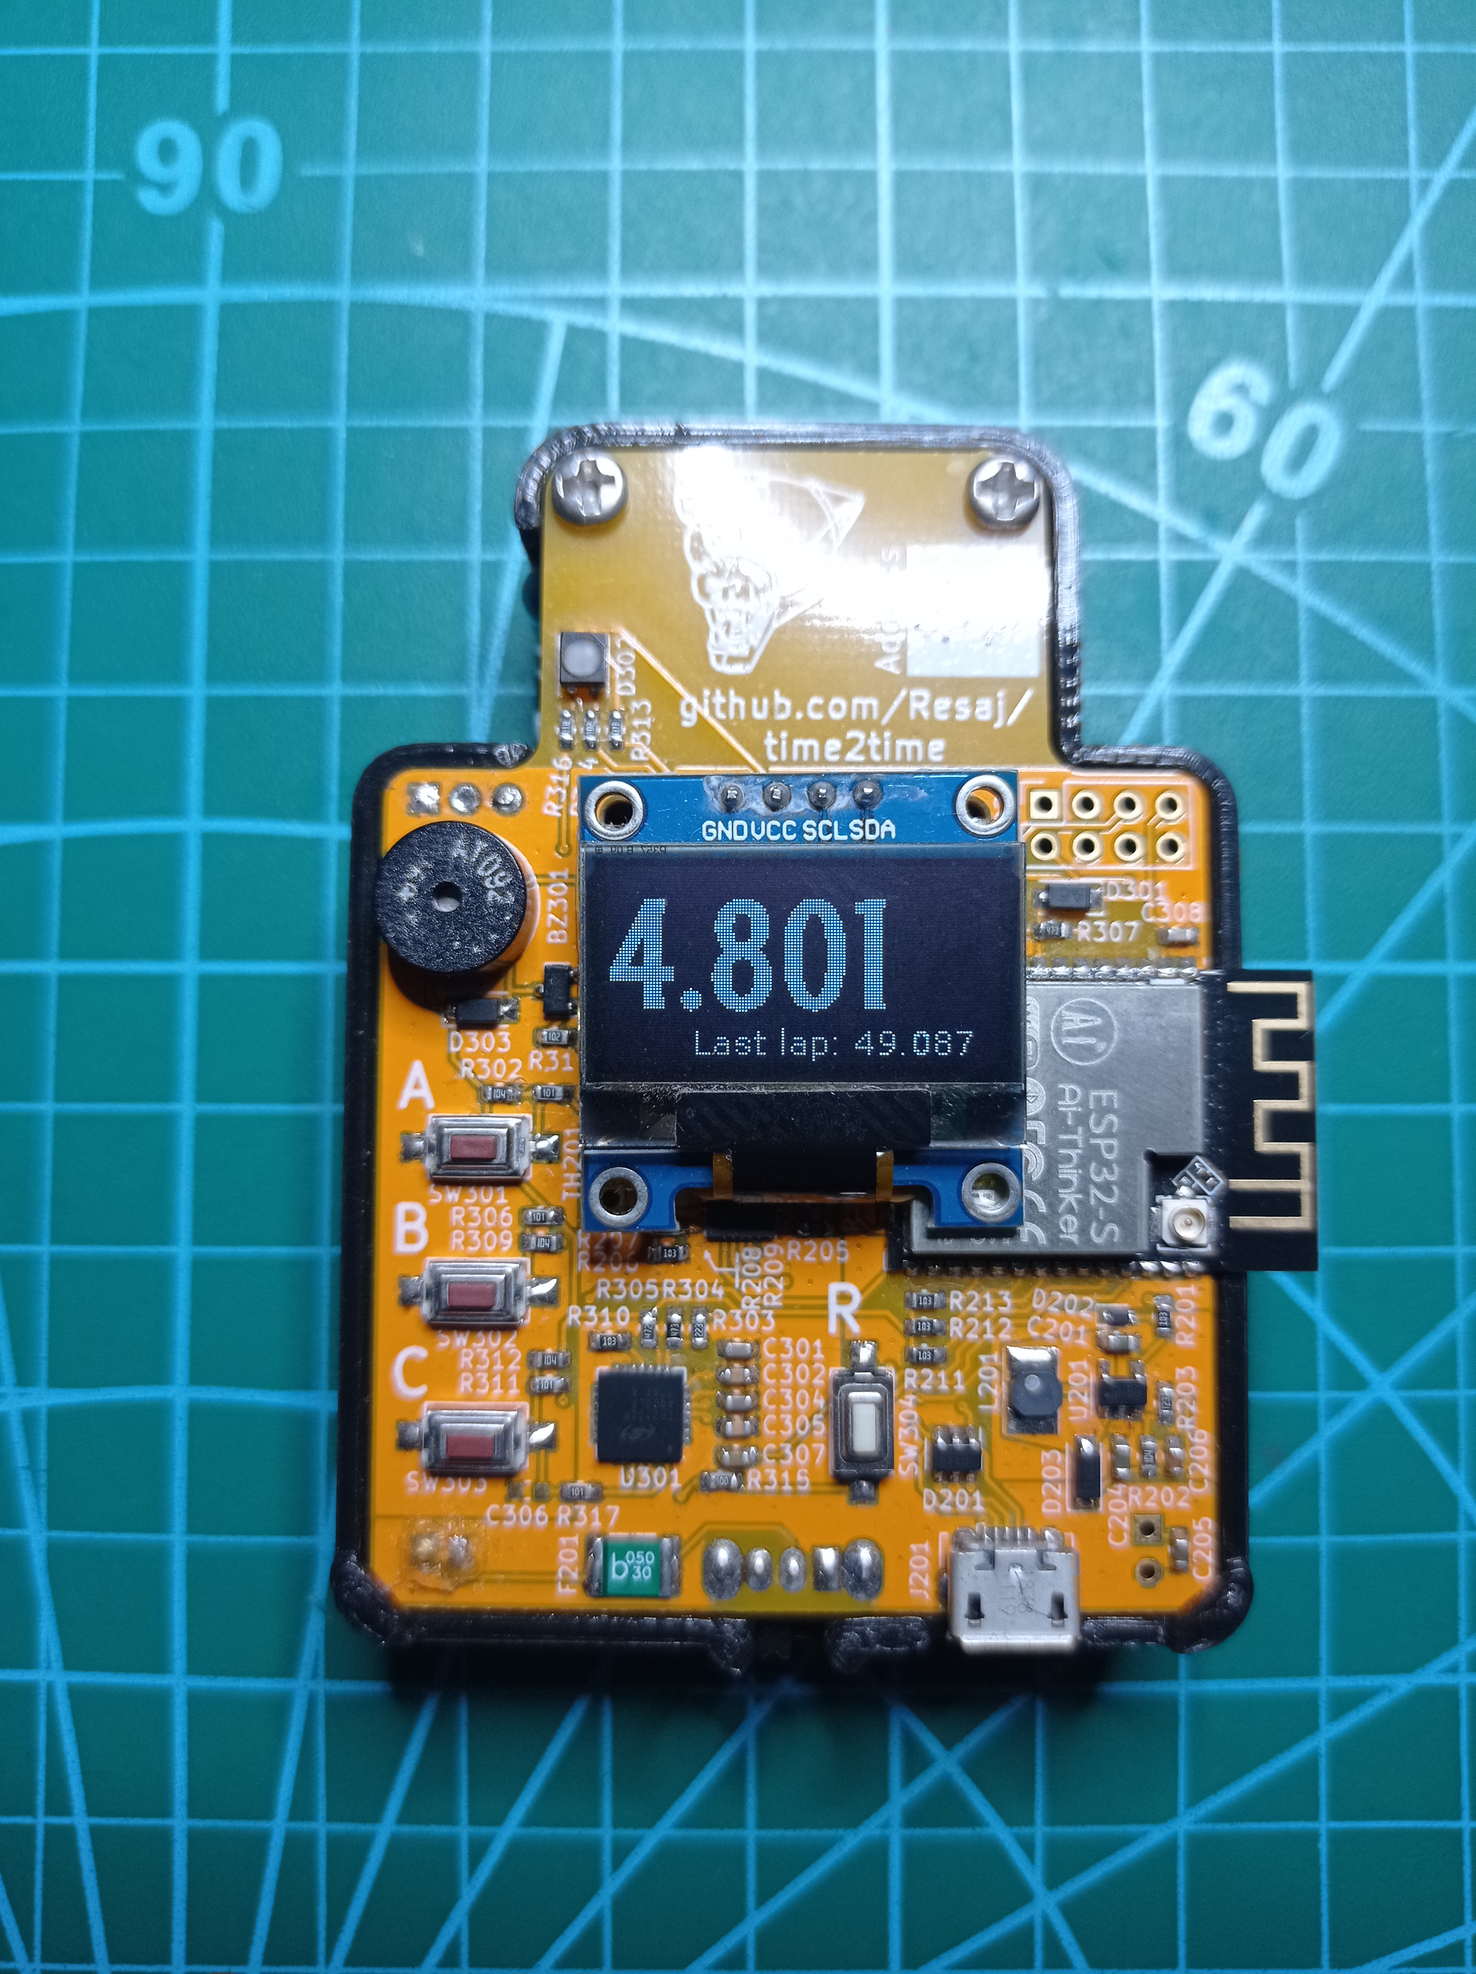
- Displays the last lap time at the bottom of the screen.
- A beep sounds at every lap detection. The beep is doubled if the lap time is record.
X laps time
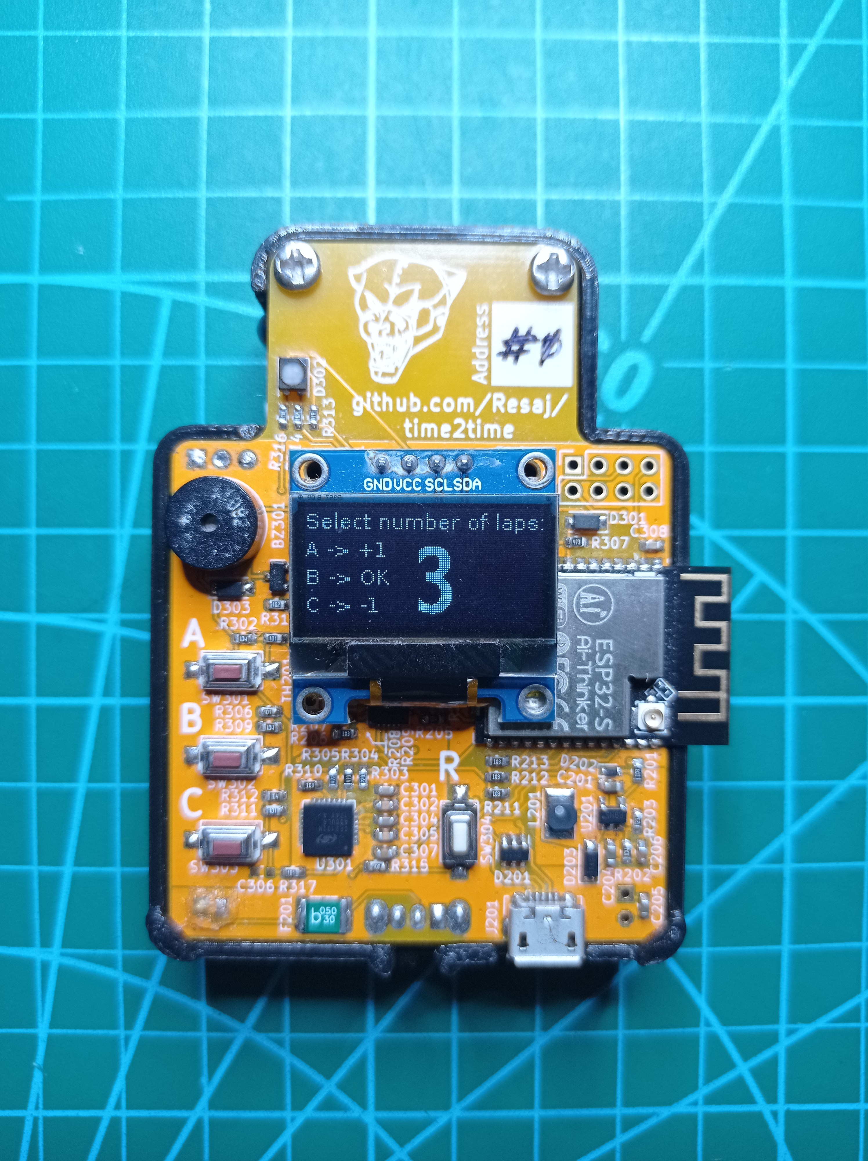
- Displays the lap time and the total time of a X-laps race in a closed circuit.
- First, the number of laps must be selected using the buttons.
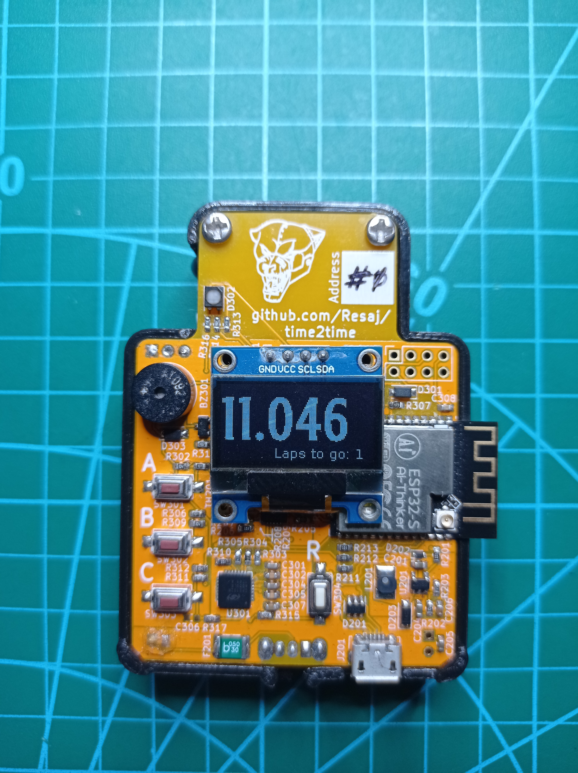
- The timing starts when the vehicle is detected. From that moment, the display will show the laps to go, in addition to race time.
- A beep sounds at every lap detection. The beep is doubled if the lap time is record.
- After the last lap beep detection, a triple beep will sound if the total time of the race is record.
- To inform that the race has finished, a long beep will sound.
- A new race can be started by pressing the B button, without getting out to the main menu.
Time trial
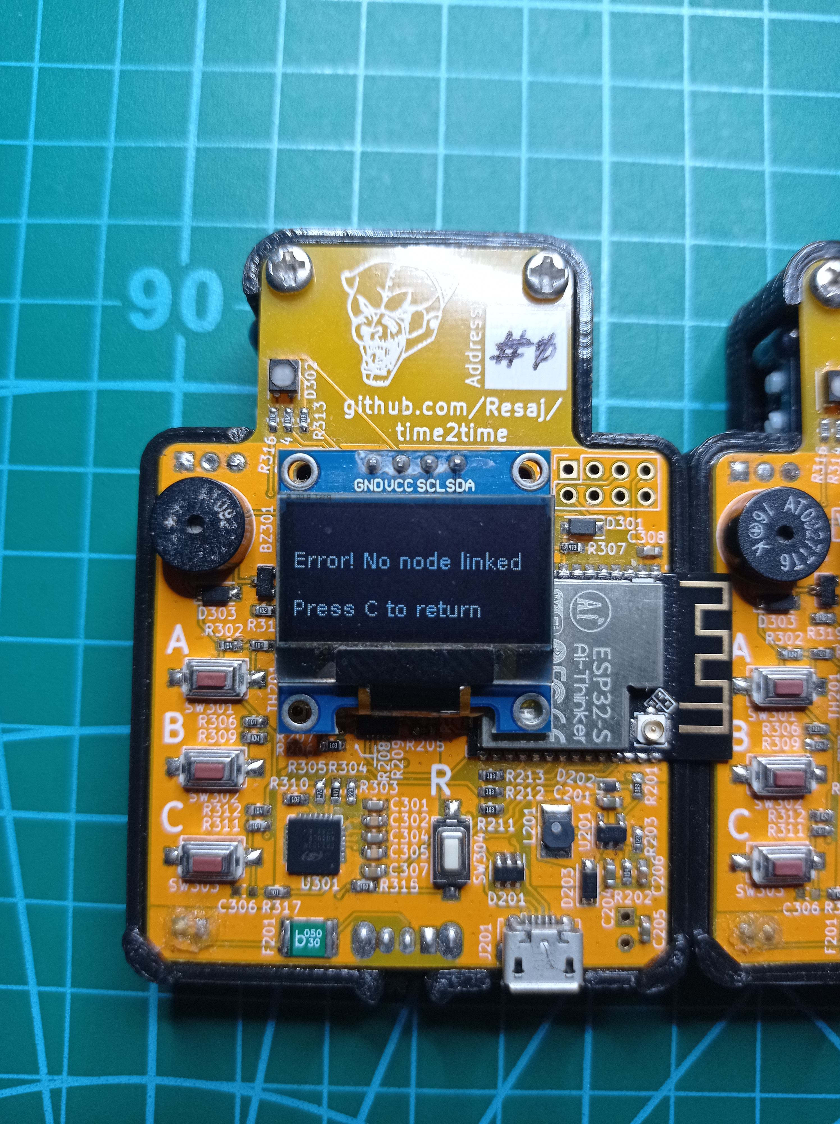
- This is a timing mode that has a different start and end points, so it is necessary to use two #time2time to execute it.
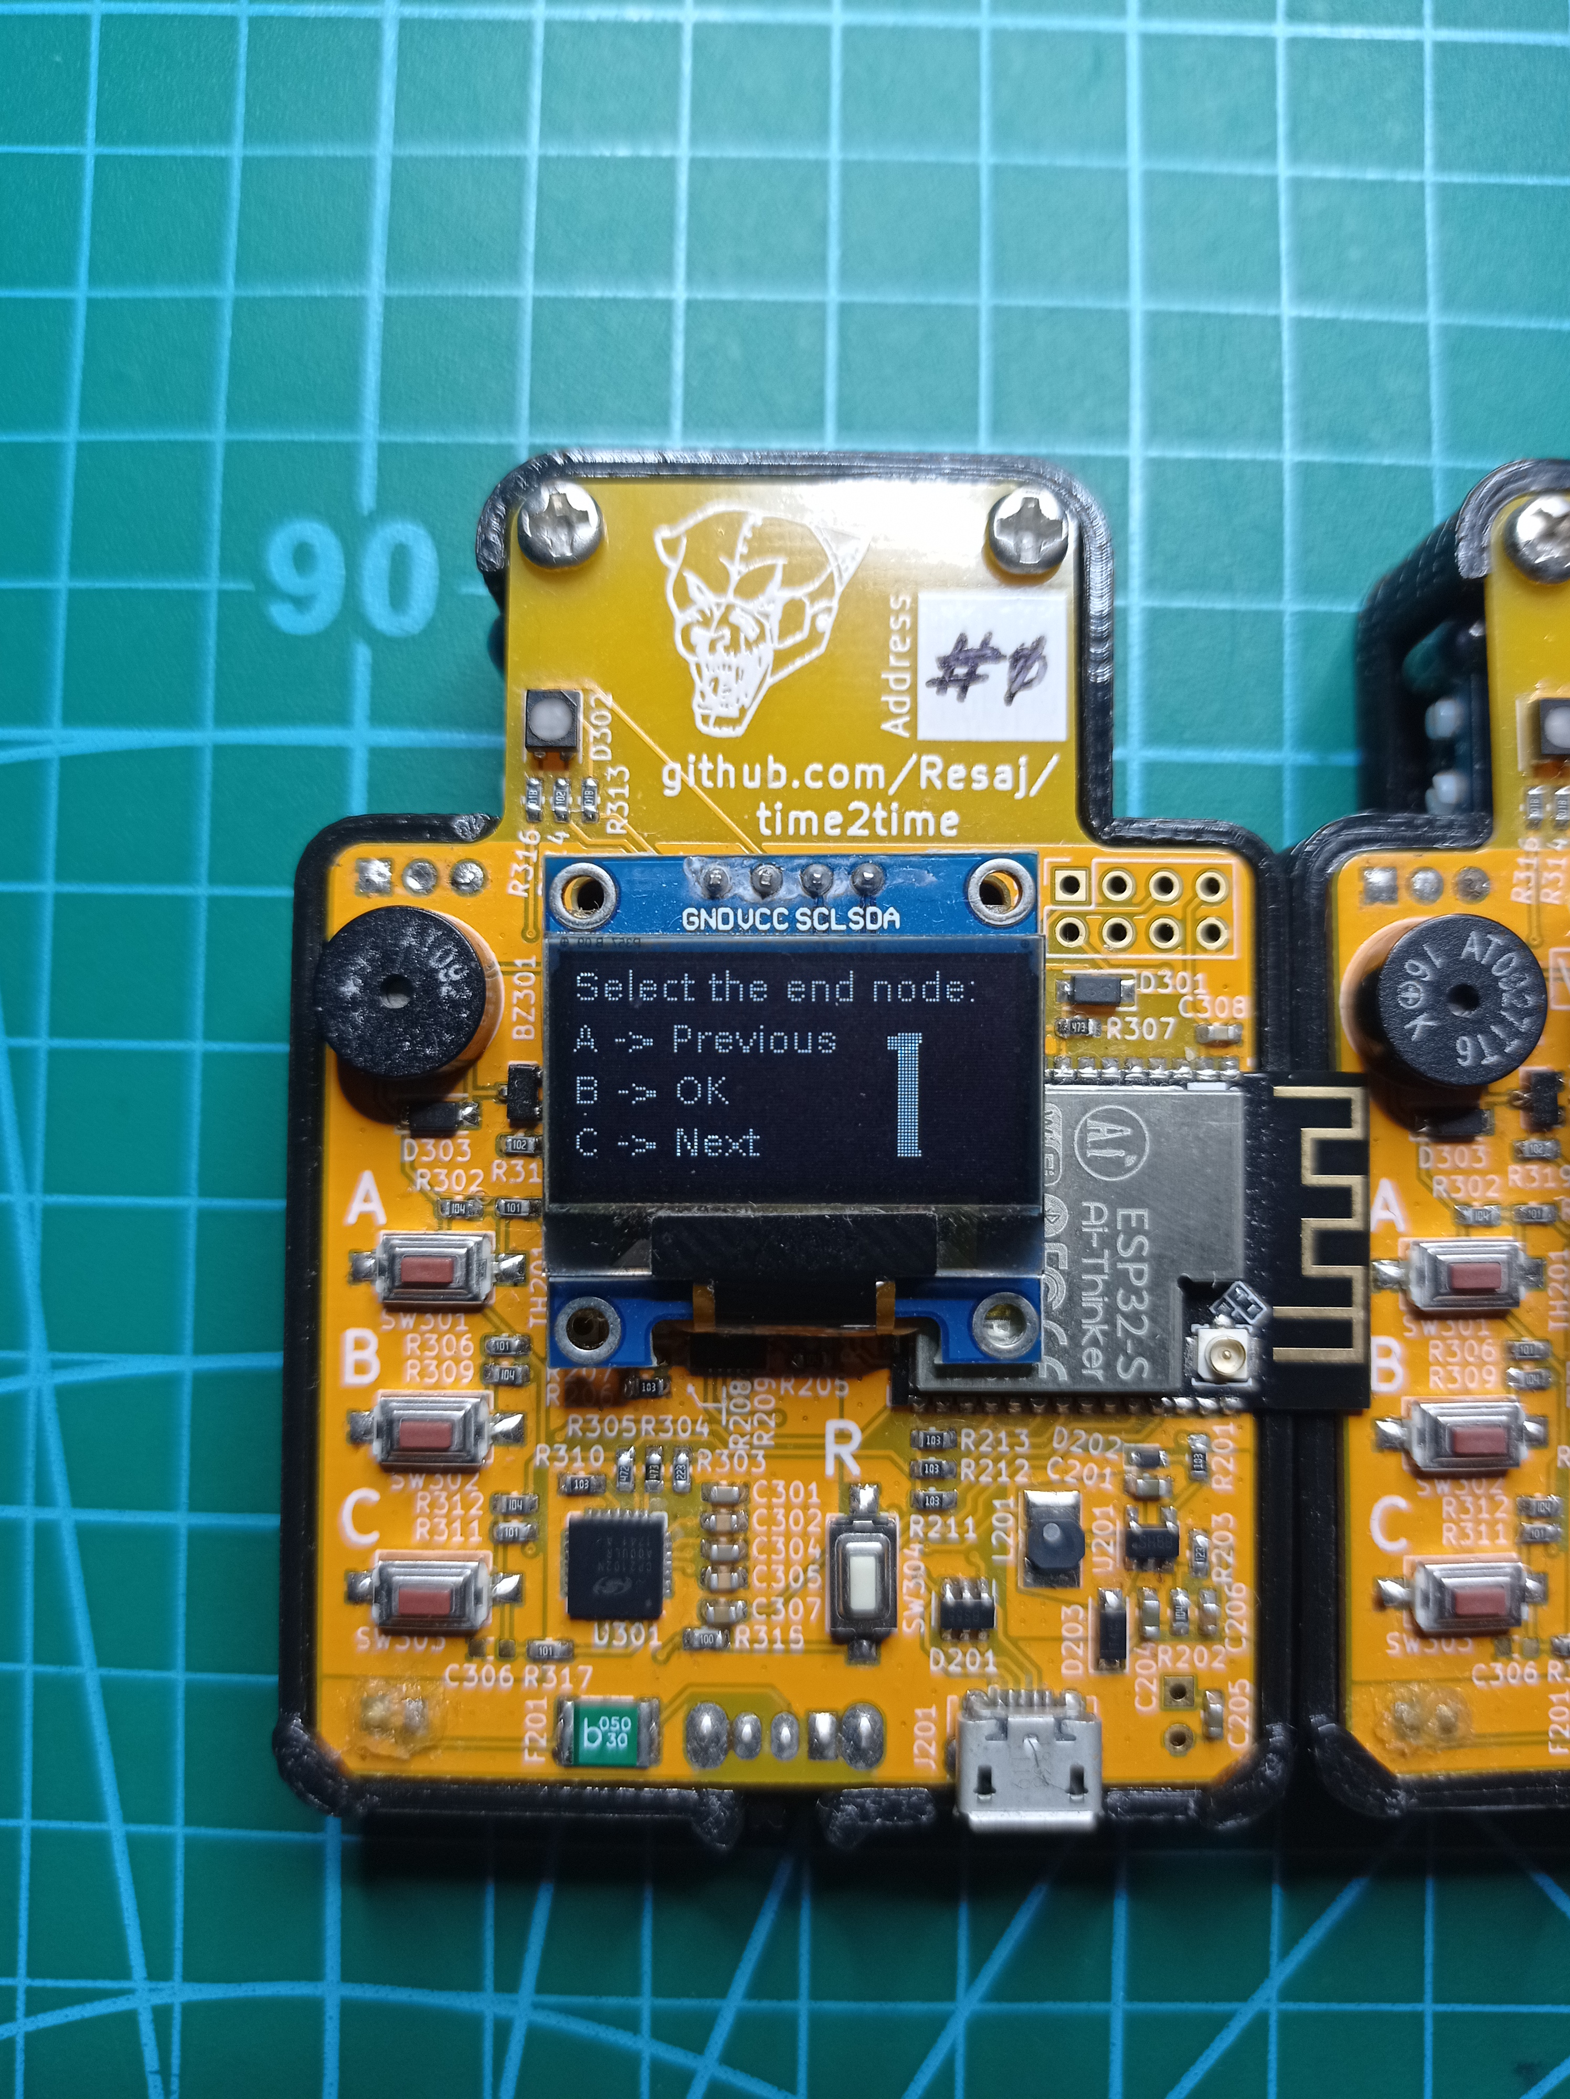
- From the start node, the final node must be selected. In the case that no #time2time nodes from the list have been detected or the connection returns an error, the problem will be shown on the screen. In the case that the link are OK, the leds of both nodes will synchronize themselves to confirm it and messages will appear on the screens.
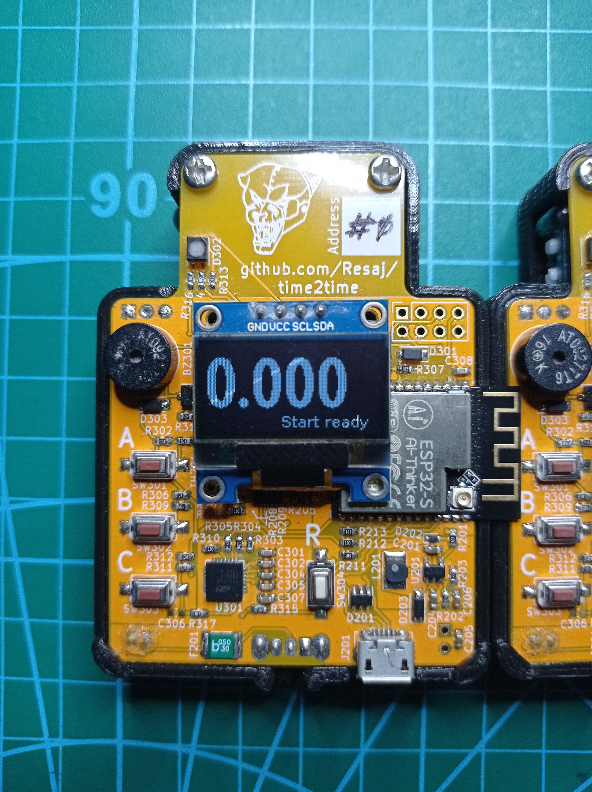
- The timing starts when the vehicle Is detected by the start node, which will beep to confirm it.
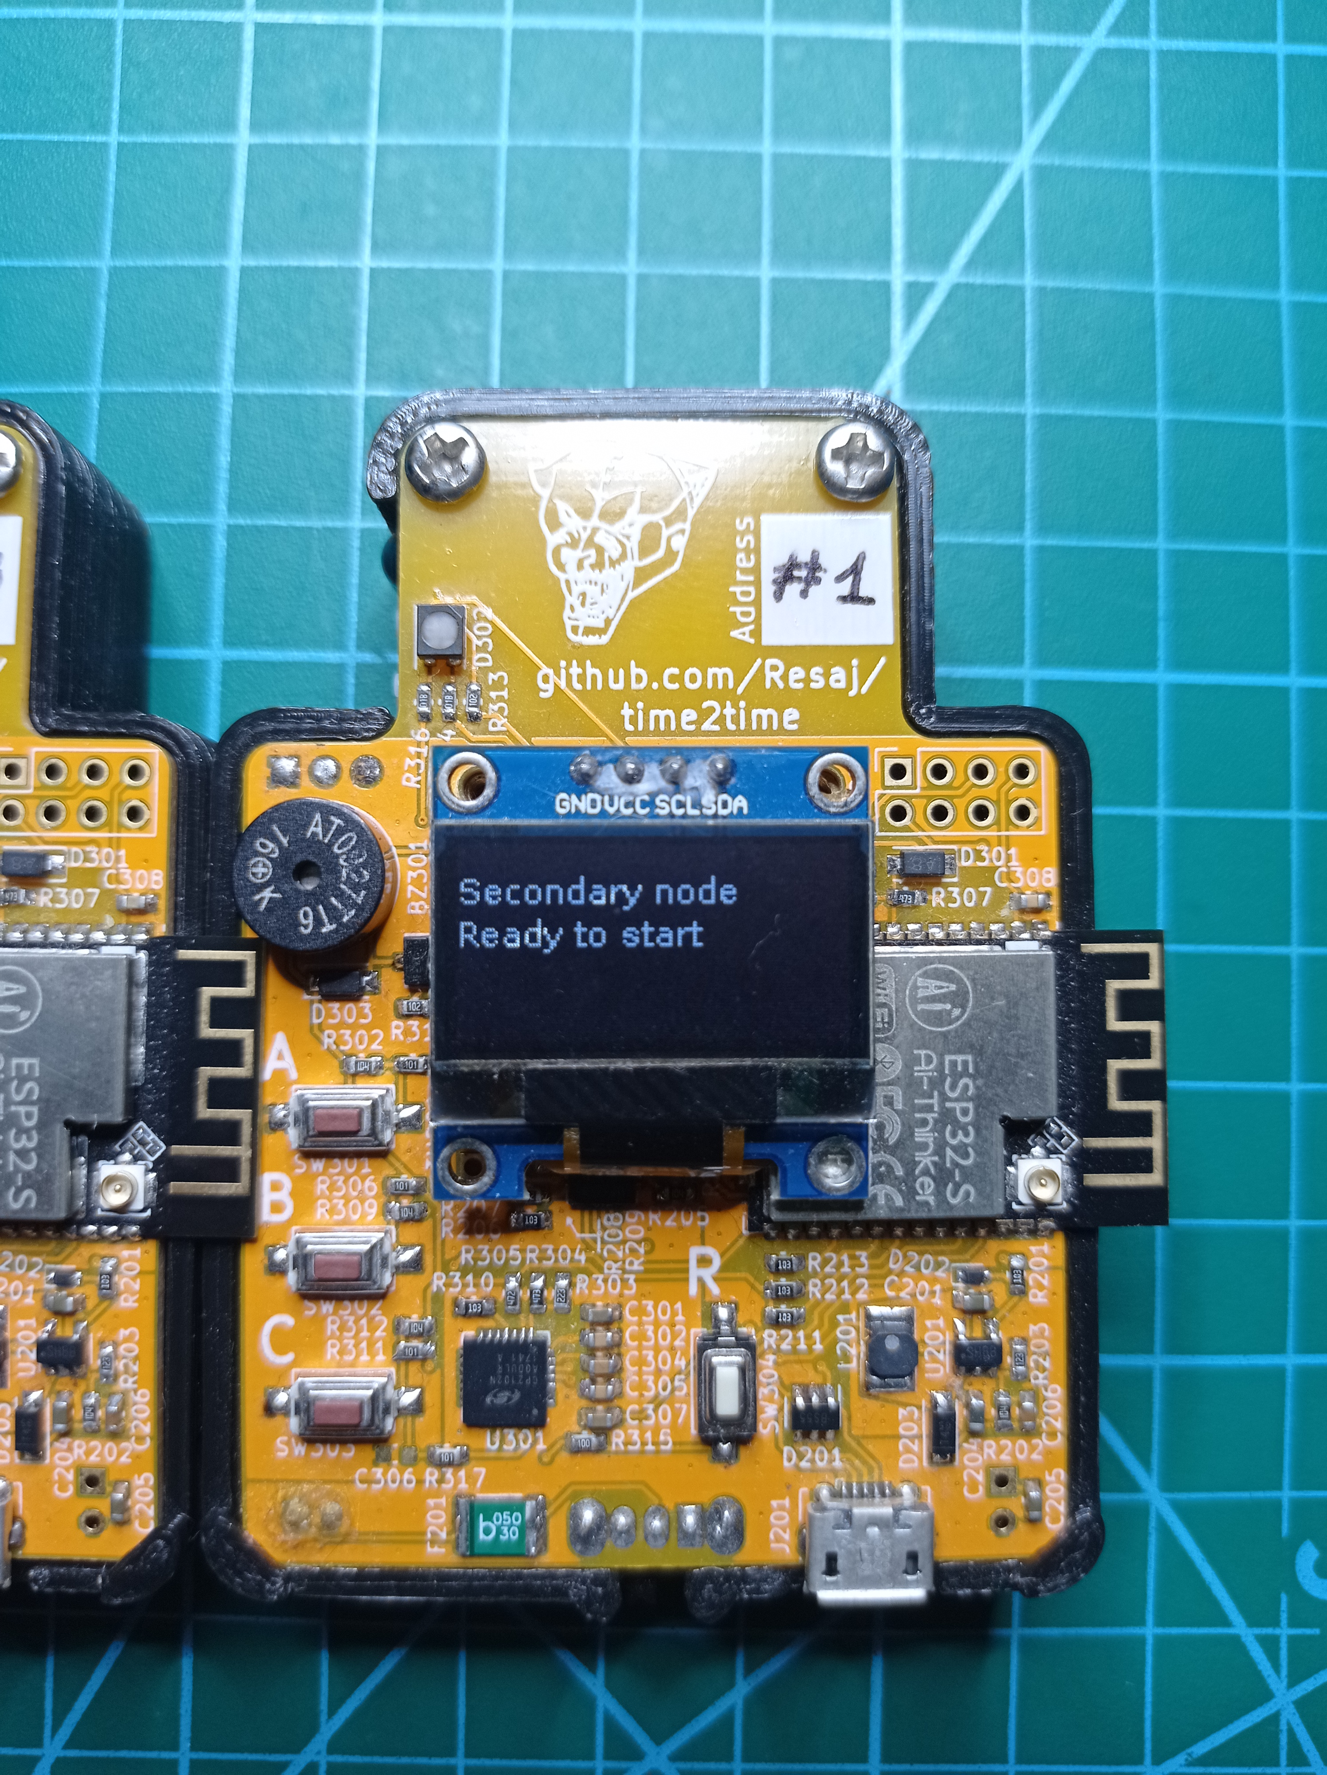
- The chronometer stops the timing when the vehicle is detected by the end node, which will make a beep sound to confirm it, or two in the case that the time is record. The total time will be shown in both nodes.
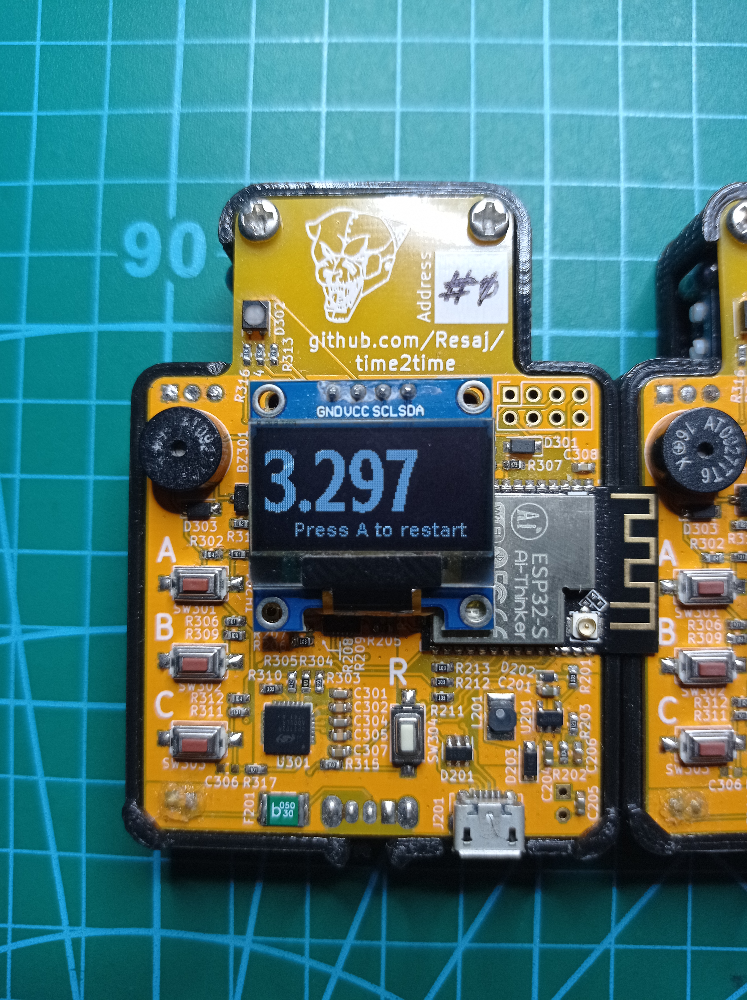
- The timing can be restarted by pressing the A button, without getting out to the main menu.
Start/Stop
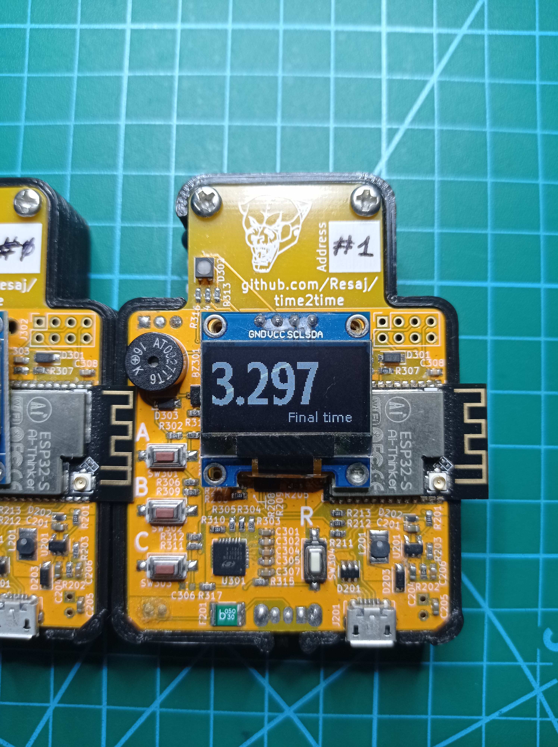
This mode is same than “Time trial” mode, but there is a little difference:
- The timing starts when the vehicle is no longer detected by the initial node. It is necessary that a vehicle is present and no longer detected for the time to start counting. If a vehicle is not detected at the start of the mode, the timing won’t start automatically.
Get toast time
- This mode gets the time in a closed circuit with the same start and end points and it only needs one #time2time.
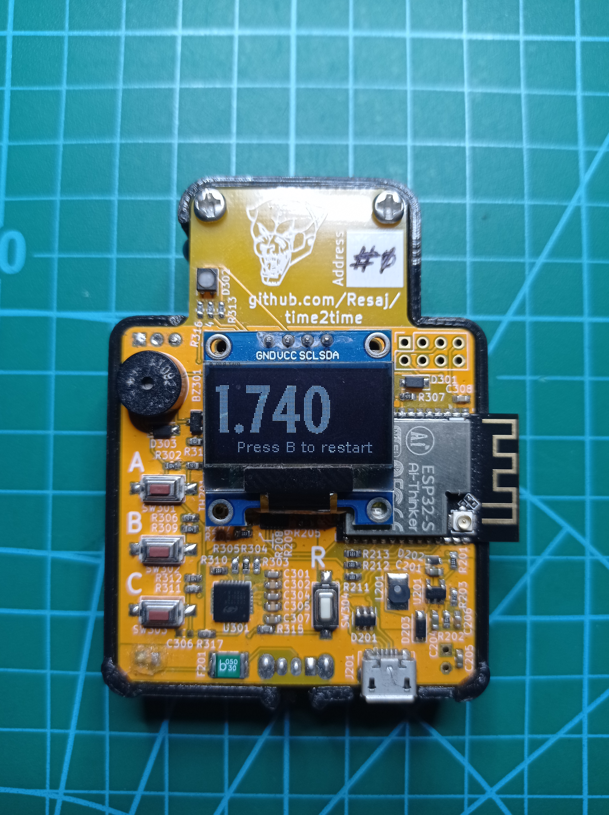
- The time starts counting the same moment than the “Start/Stop” mode, when the chronometer stops detecting the vehicle.
- The time stops when the vehicle is detected again.
- During the timing, the try can be aborted by pressing the B button.
- The timing can be restarted by pressing the B button, without getting out to the main menu.
Time2time info
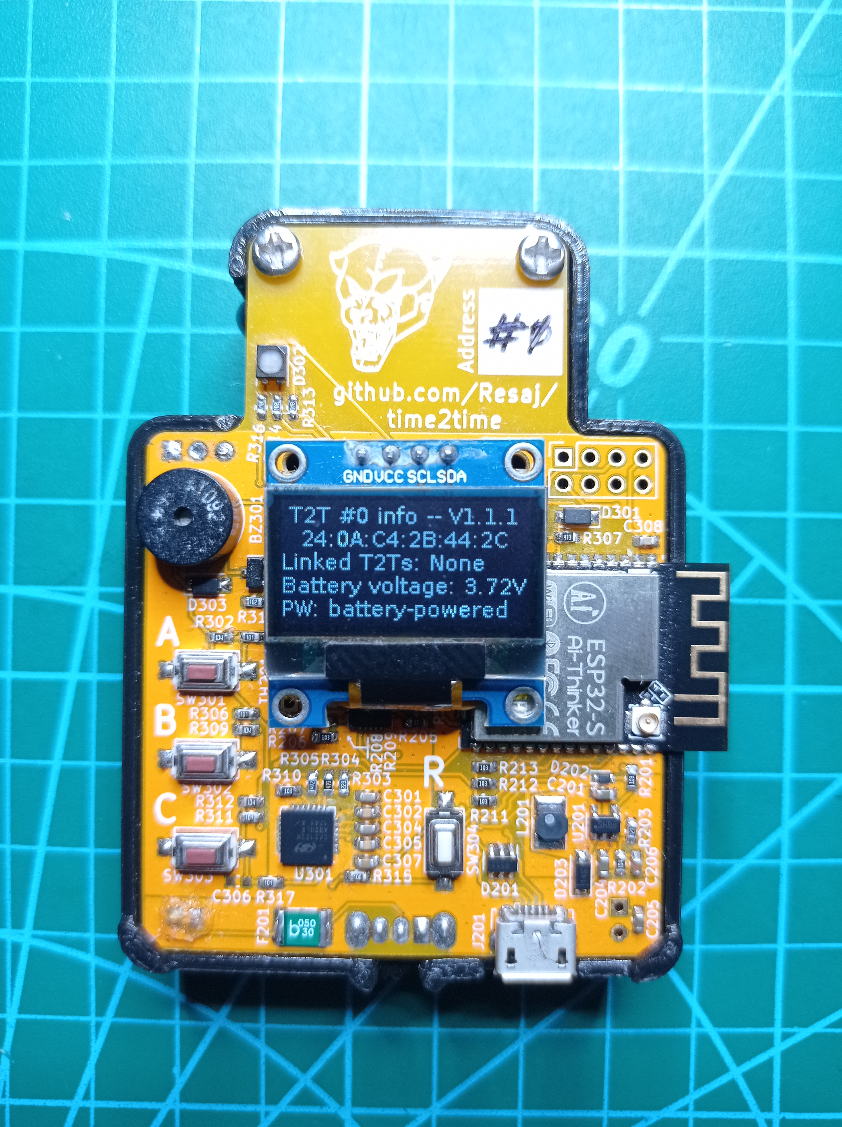
This mode displays the #time2time information:
- Node address
- Firmware version
- MAC address
- Linked #time2time nodes (it is updated every few seconds)
- Battery voltage
- Power supply mode or status
Only charge
This mode sends to sleep all the systems of the chronometer to allow a faster charge of the battery through the USB. Therefore, nothing is shown on the display while this mode remains active.
To exit this mode just click the C button.

